|  |  |
| --- | --- |
| **Name** |  |
| **CMS ID** |  |
| **Date** |  |

**Objectives:**

After completing this Lab, students will able to

1. Understand the concept and usage of Stack in programming.
2. Implement Stacks using Array.
3. Implement Stacks using linked lists.

**Stacks**

The *stack* is a very common data structure used in programs. By *data structure*, we mean something that is meant to *hold* data and provides certain *operations* on that data.

It is a sequence of items that are accessible at only one end of the sequence. Think of a stack as a collection of items that are piled one on top of the other, with access limited to the topmost item. A stack inserts item on the top of the stack and removes item from the top of the stack. It has LIFO (Last-In First-Out) ordering for the items on the stack.

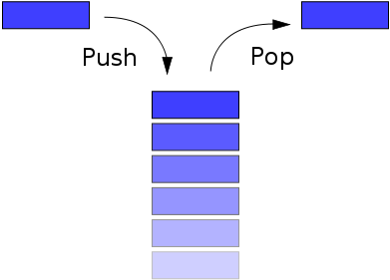

Type of Stack:

* Linear Stack (Array)
* Linked List Stack

**Objective – 2: *Implementing of Stacks using Arrays.***

**Basic Stack Operations**

There are basic 8 stack operations listed below.

* Create Stack
* Is stack Empty
* Is stack Full
* Push
* Pop
* Top
* Count Stack Elements
* Destroy Stack

**Tasks**

**Note: You should use stacks for all of these tasks**.

1. Understand the implementation of stack using both Arrays and Linked lists by following the source codes provided in the lecture ppt. In case of any confusion, do call me.
2. Create a program that takes name of a user and print it in reverse order.
3. Create a program that determine whether a word is palindrome or not. You should use linked lists for this purpose.

**Palindromes:** redivider, deified, civic, radar, level, rotor, kayak, reviver, racecar, madam, mom, and refer are palindromes.

1. Implement postfix expression evaluator that takes a string object that contain postfix expression as input and return the result of that expression. All the numbers in the expression are in the range of 0-9.

Test cases:

1. Input: 82+3*64/-=

Output: 28.5

1. Input: 2571//*87+-=  
   Output: -13.571
2. Solve the following leetCode task, provide its solution, and screenshot of acceptance

<https://leetcode.com/problems/baseball-game/>